**Statistics Assignment 3**

1. Write the Gaussian Distribution empirical formula.

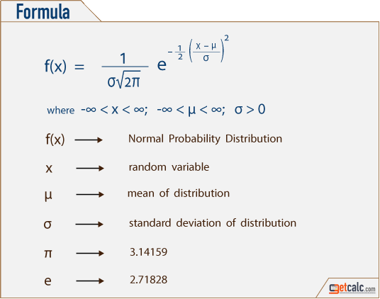

1. What is the Z-score, and why is it important?

A z-score describes the position of a raw score in terms of its distance from the mean, when measured in standard deviation units. The z-score is positive if the value lies above the mean, and negative if it lies below the mean.

It is also known as a standard score, because it allows comparison of scores on different kinds of variables by standardizing the distribution. A standard normal distribution (SND) is a normally shaped distribution with a mean of 0 and a standard deviation (SD) of 1

It is useful to standardized the values (raw scores) of a normal distribution by converting them into z-scores because:

(a) it allows researchers to calculate the probability of a score occurring within a standard normal distribution;

(b) and enables us to compare two scores that are from different samples (which may have different means and standard deviations).

3. What is an outlier, exactly?

An outlier is an observation that lies an abnormal distance from other values in a random sample from a population. In a sense, this definition leaves it up to the analyst (or a consensus process) to decide what will be considered abnormal. Before abnormal observations can be singled out, it is necessary to characterize normal observations.

1. What are our options for dealing with outliers in our dataset?
2. Set up a filter in your testing tool
3. Remove or change outliers during post-test analysis
4. Change the value of outliers
5. Consider the underlying distribution
6. Consider the value of mild outliers

5. Write the sample and population variances equations and explain Bessel

Correction.

In statistics, Bessel's correction is the use of n − 1 instead of n in the formula for the sample variance and sample standard deviation, where n is the number of observations in a sample. This method corrects the bias in the estimation of the population variance. It also partially corrects the bias in the estimation of the population standard deviation. However, the correction often increases the mean squared error in these estimations. This technique is named after Friedrich Bessel.

